Experimental String Library for ESP32forth
ESP32forth is a powerful forth tool set created by Bradley D Nelson and the late Dr. Hanson Ting for the low cost ESP32 module. This document is a word glossary of a String Library created by Mark Wills in 2014 and now adapted for ESP32forth by Bob Edwards in 2022.  The headings and words in the following table are in alphabetic order to speed up searches. Use ctrl F to search for a specific word. Immediate words (that run at compile time) are shown in red. The right-hand column indicates the ESP32forth vocabulary in which the word is located.  Any contributions welcome via the Forth2020 forum on Facebook | 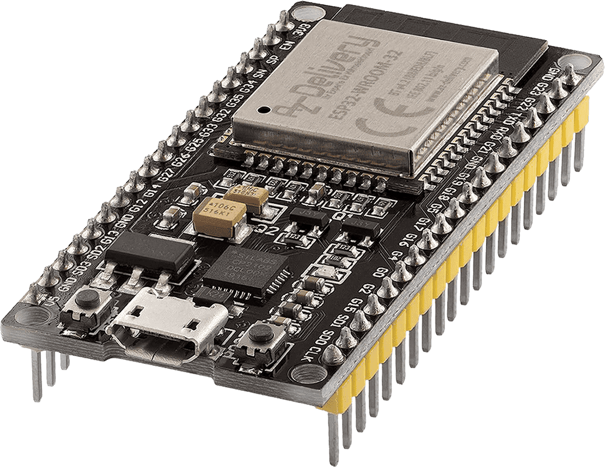  ESP32 is a series of low-cost, low-power system on a chip microcontrollers with integrated Wi-Fi and dual-mode Bluetooth. The ESP32 series employs either a Tensilica Xtensa LX6 microprocessor in both dual-core and single-core variations, Xtensa LX7 dual-core microprocessor or a single-core RISC-V microprocessor and includes built-in antenna switches, RF balun, power amplifier, low-noise receive amplifier, filters, and power-management modules.

Forward
When attempting to manipulate text files, the standard ESP32forth has very few string functions. This code was found on the internet and adapted for ESP32forth as an experiment. There were a few bugs that are hopefully now fixed – I’ve hand checked all the words with some strings. The library includes the interesting idea of having a separate string stack, which I found was very easy to use. This stack is easily inspected with the word $.S .

Modification to the ESP32forth Source Code
The U< word is needed to support this library. Add the following line to the ESP32forth source code underneath the definition for 0<> :-
X("U<", ULESS, tos = (ucell_t) *sp < (ucell_t) tos ? -1 : 0; --sp) \
Reload your ESP32 using the Arduino IDE with the modified source and you’re good to go.

Strings – glossary
In addition to these words, there are quite a number of ‘worker’ words in round brackets added to the Internals vocabulary. They wouldn’t normally be useful to an application programmer, so are not listed here. However, if you want to expand the library, then check the source code for further details. In the stack notation below – please note both the data stack and the string stack (ss) effects are shown:-
-rot$ | ( -- ) ( ss: s3 s2 s1 -- s1 s3 s2) | Rotates the top three string to the right | forth
:=" | ( $Caddr "string" -- ) | Assigns the string "string" to the string constant.  e.g. msg :=" hello mother!"  N.B. Don’t use in a definition only interpreted | forth
.$ | ( -- ) ( ss: str -- ) | Pop and display the topmost string from string stack | forth
.$const | ( $Caddr -- ) | Displays the string constant. e.g. fred .$const | forth
+$ | ( -- ) ( ss: s1 s2 -- s2+s1) | Replaces the top most two strings on the string stack with their concatenated equivalent | forth
==$? | ( -- flag ) ( ss: -- ) | Performs a case-sensitive comparison of the topmost two strings on the string stack, returning true if their length and contents are identical,  otherwise returning false | forth
>$ | ( $Caddr -- ) | Moves a string constant to the string stack | forth
>$const | ( $Caddr -- ) ( ss: str -- ) | Move top of string stack to the string constant | forth
$.s | ( -- ) ( ss: -- ) | Non-destructively displays the string stack | forth
$" | ( "string" -- ) | Pushes a string directly to the string stack.  e.g. $" hello world" .$ | forth
$>n | ( -- n ) ( ss: str -- ) | Interprets the topmost string as a number, returning its value on the data stack as a signed integer | forth
$const | ( max_len "name" -- ) | Creates a string constant. When "name" is referenced the address of the max_len field is pushed to the stack.  e.g. 100 string msg  The above creates a string called msg with capacity for 100 characters. | forth
$trim | ( -- ) ( ss: s1 -- s2 ) | Remove both leading and trailing spaces from s1, resulting in s2 | forth
clen$ | ( $Caddr -- len ) | Given the address of a string constant, returns its length | forth
depth$ | ( -- $sDepth) | Returns the depth of the string stack | forth
drop$ | ( -- ) ( ss: str -- ) | Drops the top string from the string stack | forth
dup$ | ( -- ) ( ss: s1 -- s1 s1) | Duplicates a string on the string stack | forth
find$ | ( offset -- pos|-1 ) ( ss: s1 s2 -- s1) | Searches string s1, beginning at offset, for the substring s2. If the string is found, returns the position of the string relative  \ to the offset, otherwise returns -1 | forth
findc$ | ( char -- pos|-1 ) ( ss: -- ) | Returns the first occurance of the character char in the top string. The string is retained. Returns -1 if the char is not found | forth
lcase$ | ( -- ) ( ss: STR -- str) | On the topmost string, converts all upper case characters to lower case | forth
left$ | ( len -- ) ( ss: str1 -- str1 str2) | The leftmost len characters are pushed to the string stack as a new string. The original string is retained | forth
len$ | ( -- len ) ( ss: -- ) | Returns the length of the topmost string | forth
ltrim$ | ( -- ) ( ss: s1 -- s2 ) | Removes leading spaces from s1, resulting in s2 | forth
maxLen$ | ( $Caddr -- max_len ) | Given the address of a string constant, returns its maximum length | forth
mid$ | ( start len -- ) ( ss: str1 -- str1 str2) | The word mid$ produces a sub-string on the string stack, consisting of the characters from the topmost string starting at character start and ending at character end | forth
n>$ | ( n -- ) ( ss: -- str ) | Pushes the signed number on the data stack to the string stack
nip$ | ( -- ) ( ss: s1 s2 -- s2) | Remove the string under the top string | forth
over$ | ( -- ) ( ss: s1 s2 -- s1 s2 s1) | Move a copy of s1 to top of string stack | forth
pick$ | ( n -- ) ( ss: -- strN) | Given an index into the string stack, copy the indexed string to the top of the string stack.  0 $pick is equivalent to $DUP  1 $pick is equivalent to $OVER etc. | forth
replace$ | ( -- pos ) ( found: ss: s1 s2 s3 -- s4 not found: s1 s2 -- s1 s2) | In string s2 find s3 and replace with s1, resulting in s4. If a replacement is made, the starting position of the replacement is returned, otherwise -1 is returned | forth
rev$ | ( -- ) ( ss: s1 -- s2 ) | Reverse topmost string on string stack | forth
right$ | ( len -- ) ( ss: str1 -- str1 str2) | The rightmost len characters, pushed to the string stack as a new string. The original string is retained | forth
rot$ | ( -- ) ( ss: s3 s2 s1 -- s2 s1 s3) | Rotates the top three string to the left | forth
rtrim$ | ( -- ) ( ss: s1 -- s2 ) | Removes trailing spaces from s1, resulting in s2 | forth
swap$ | ( -- ) ( ss: s1 s2 -- s2 s1) | Swaps the top two string items on the string stack | forth
ucase$ | ( -- ) ( ss: str -- STR) | On the topmost string, converts all lower case characters to upper case | forth

String Stack Internals

With two strings on the stack, the contents is:-

Length of string1 | ← ($sp@) points here | ← Lowest address is top of stack
s
t
r
I
n
g
1
padding if reqd
Length of string2
S  t  r  I  n  g  2  padding if reqd |  | ← Highest address

N.B. the length cells contain ( No. of chrs + length cell + any padding) in bytes.

